**Virtual Private Network (VPN) Lab**

Task 1: VM Setup

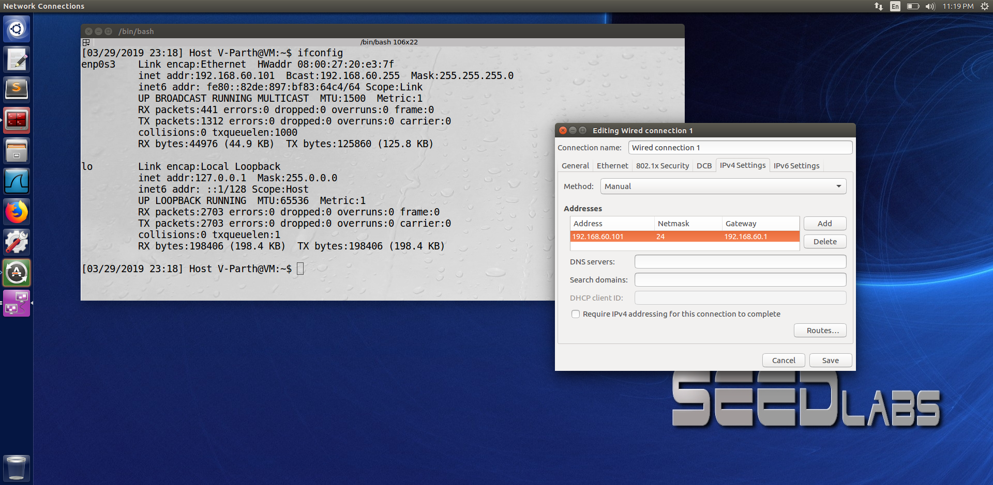

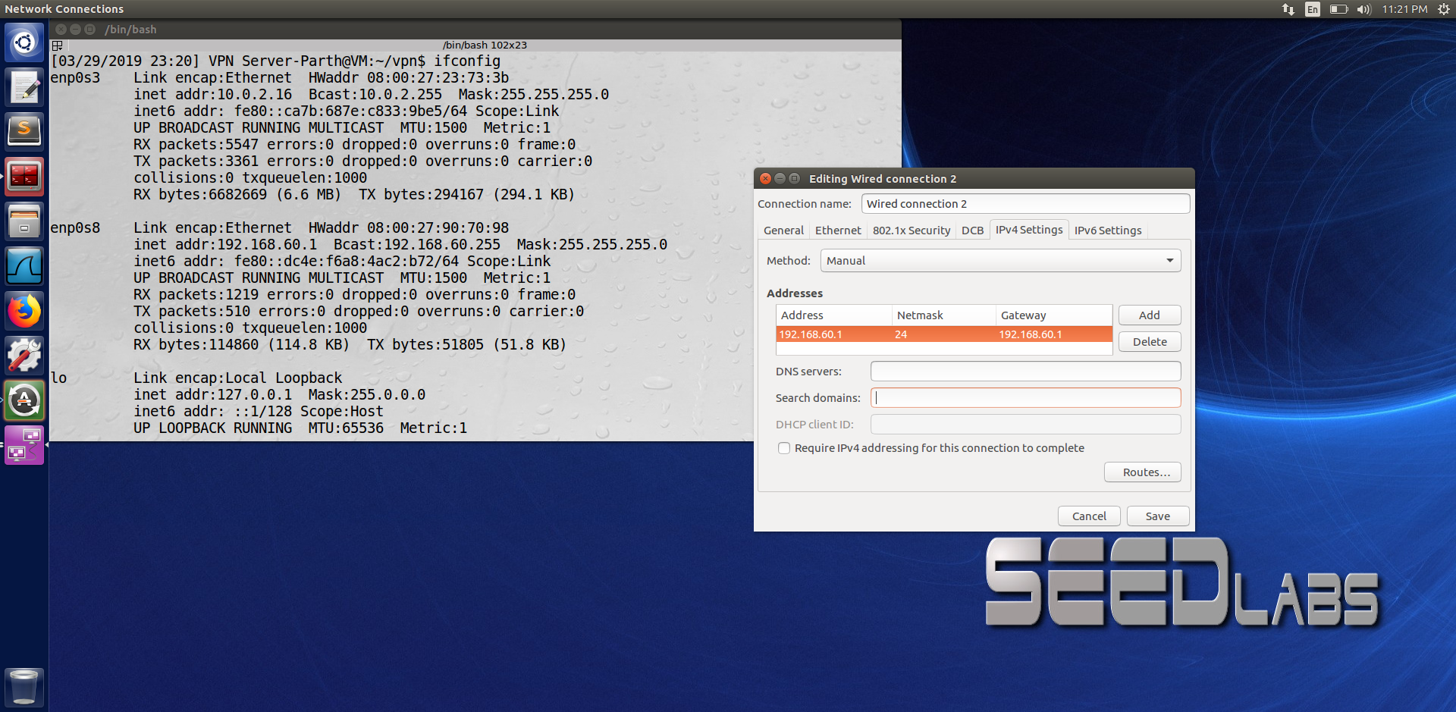

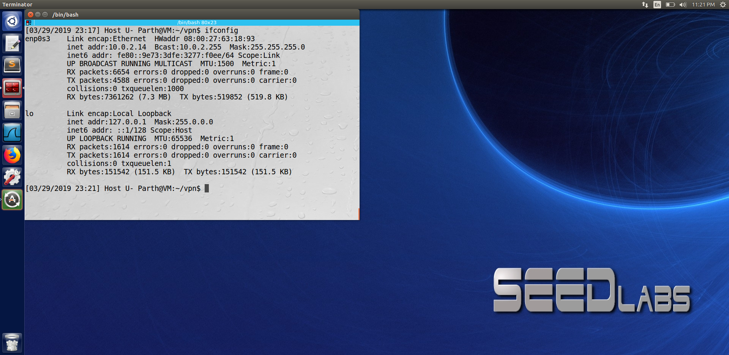

In this task we set up 3 VM’s. The first is the Host U (which also is VPN Client), VPN server and Host V(which is the internal network). Host U will not be able to connect to Host V as Host V is the internal Network.

Task 2

Step 1 : Run VPN Server

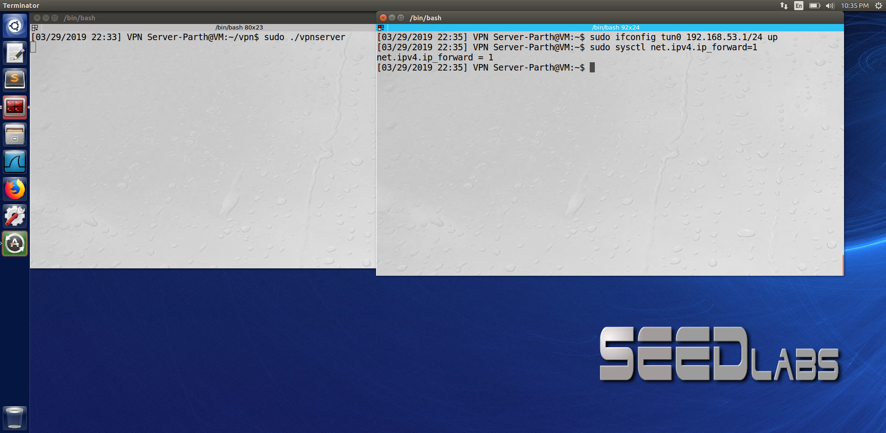

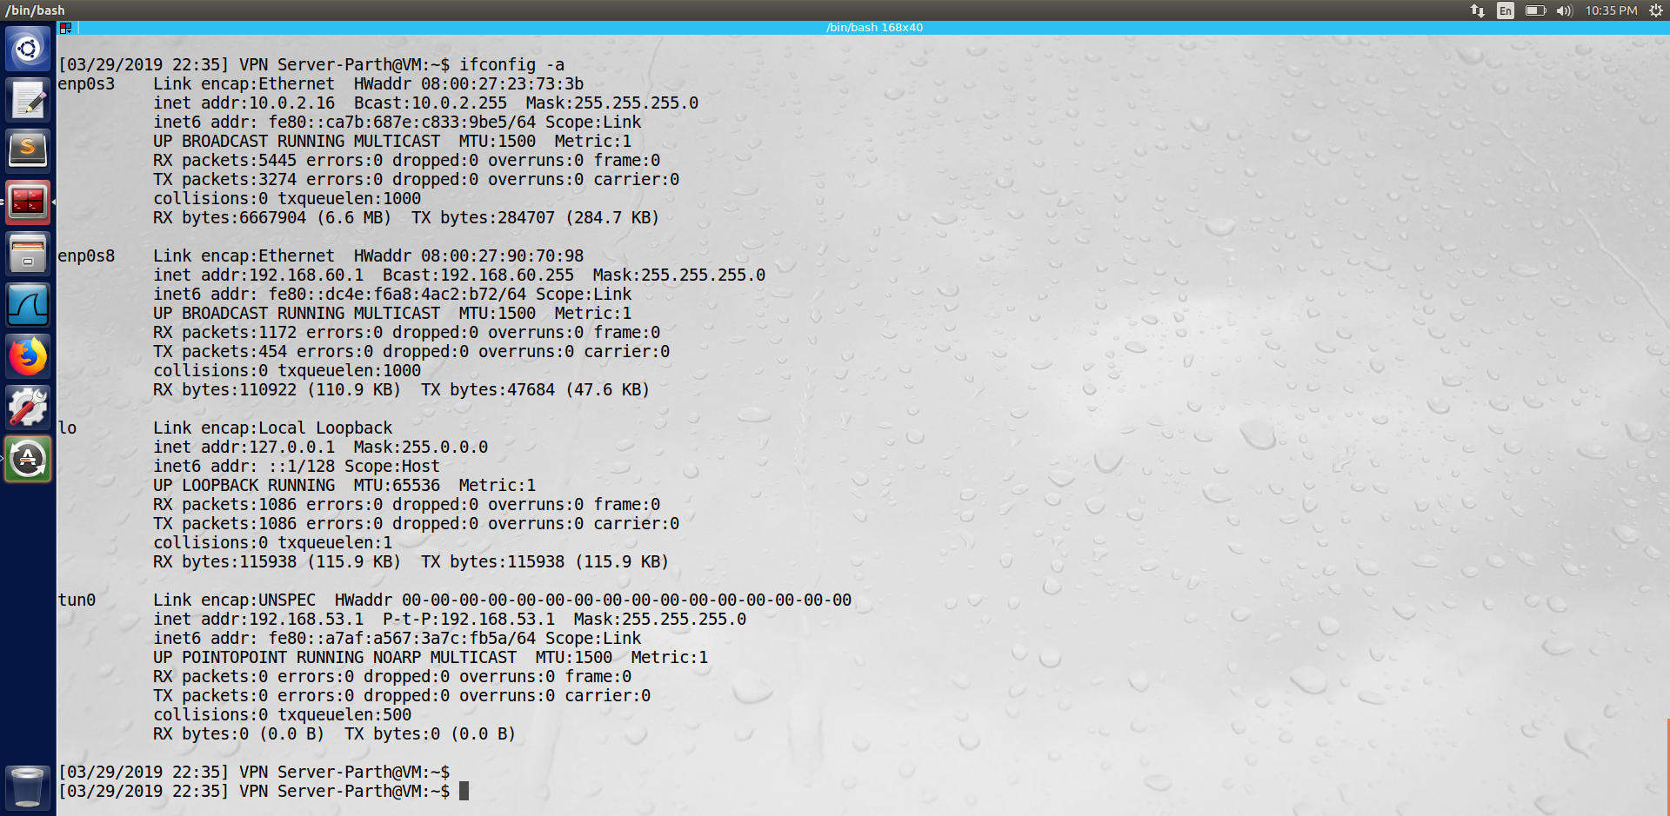

We first run the vpn server using the command ‘sudo ./vpnserver’ once we execute this command we then assign an IP to the TUN0 interface and turn on the IP forwarding as seen from the screenshot above.

Step 2 : Run VPN Client

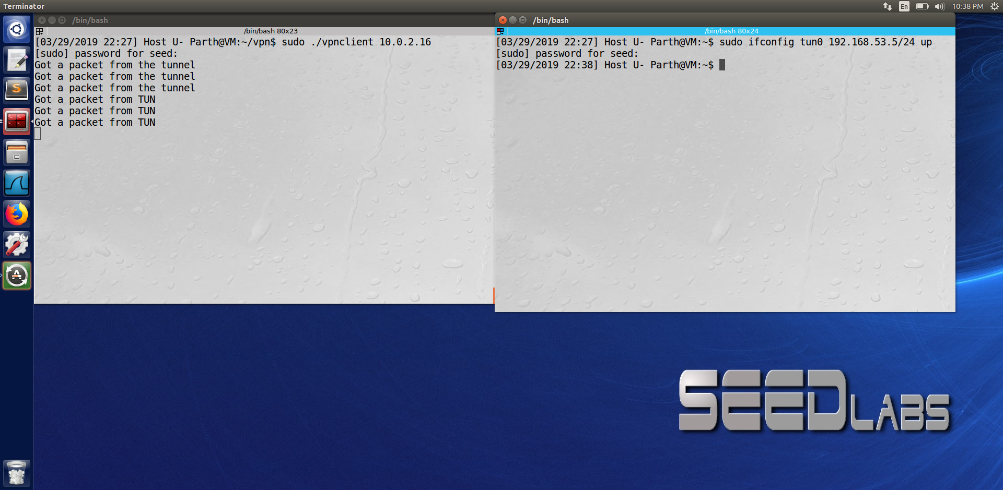

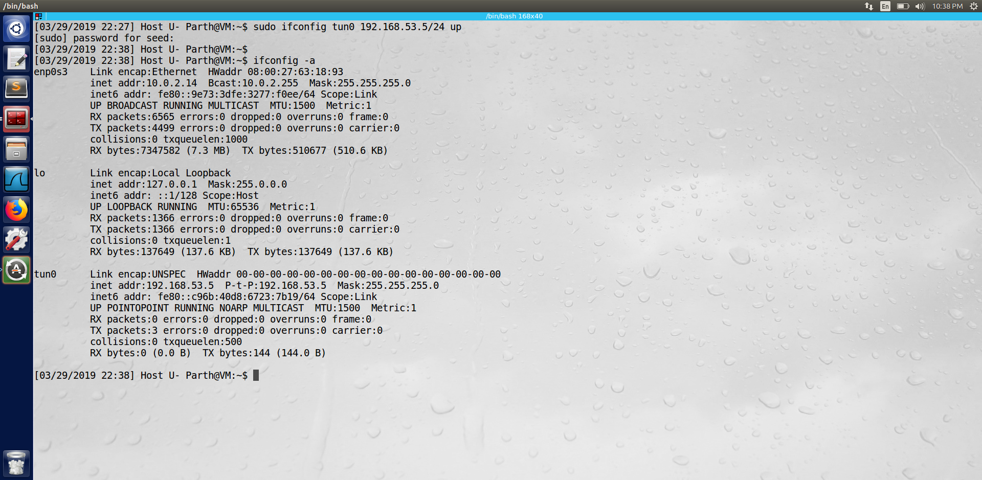

Now on the Host U machine we do the same thing as that in step 1 i.e., we first run the vpnclient and then assign an IP to the tun0 interface as seen above.

Step 3 : Setup Routing On Client and Server VM’s:

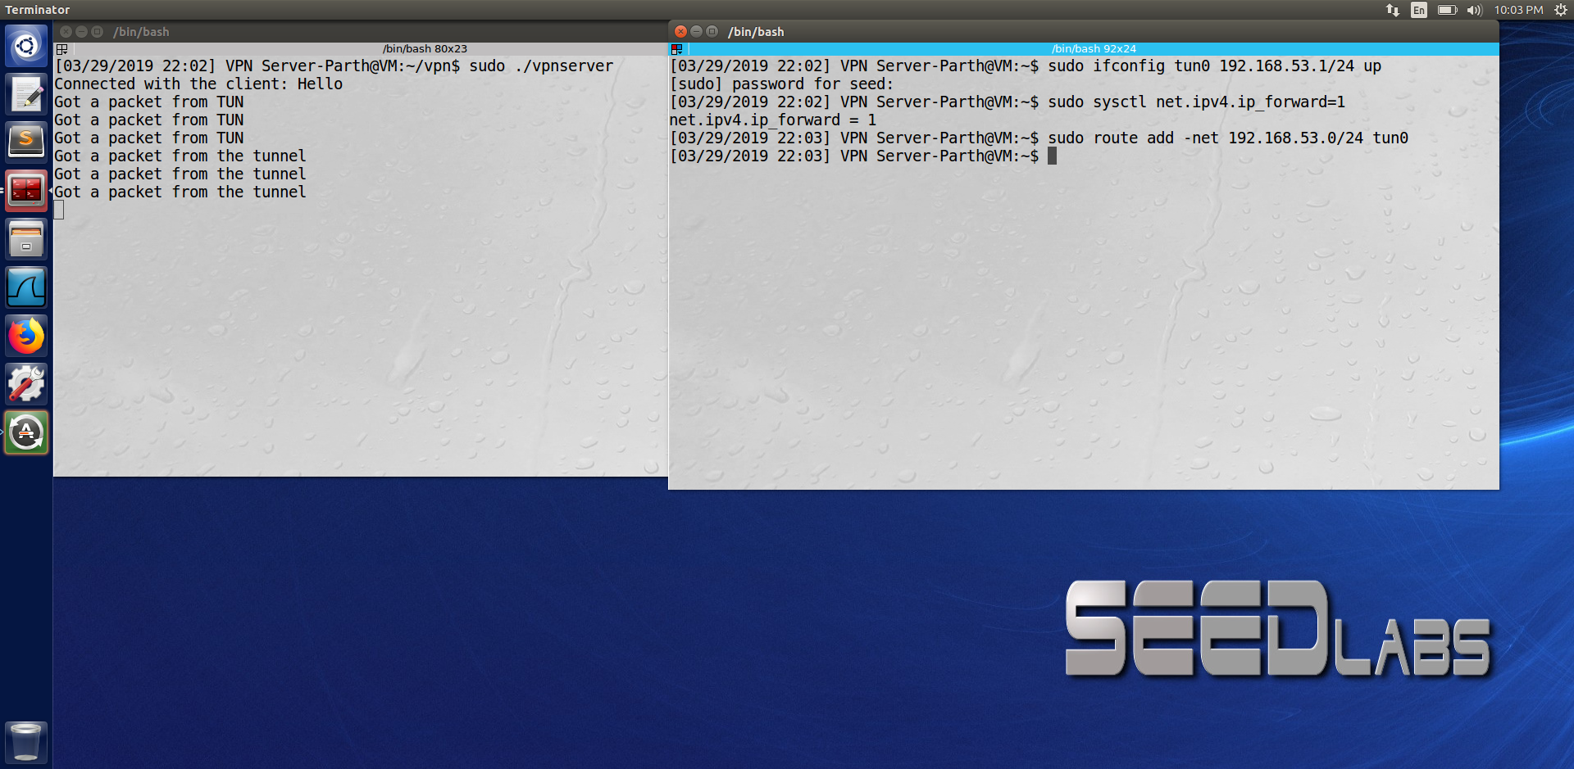

The last command in the above screenshot sets the routing path for the server machine to direct the intended traffic of IP 192.168.53.0/24 to go through tun0

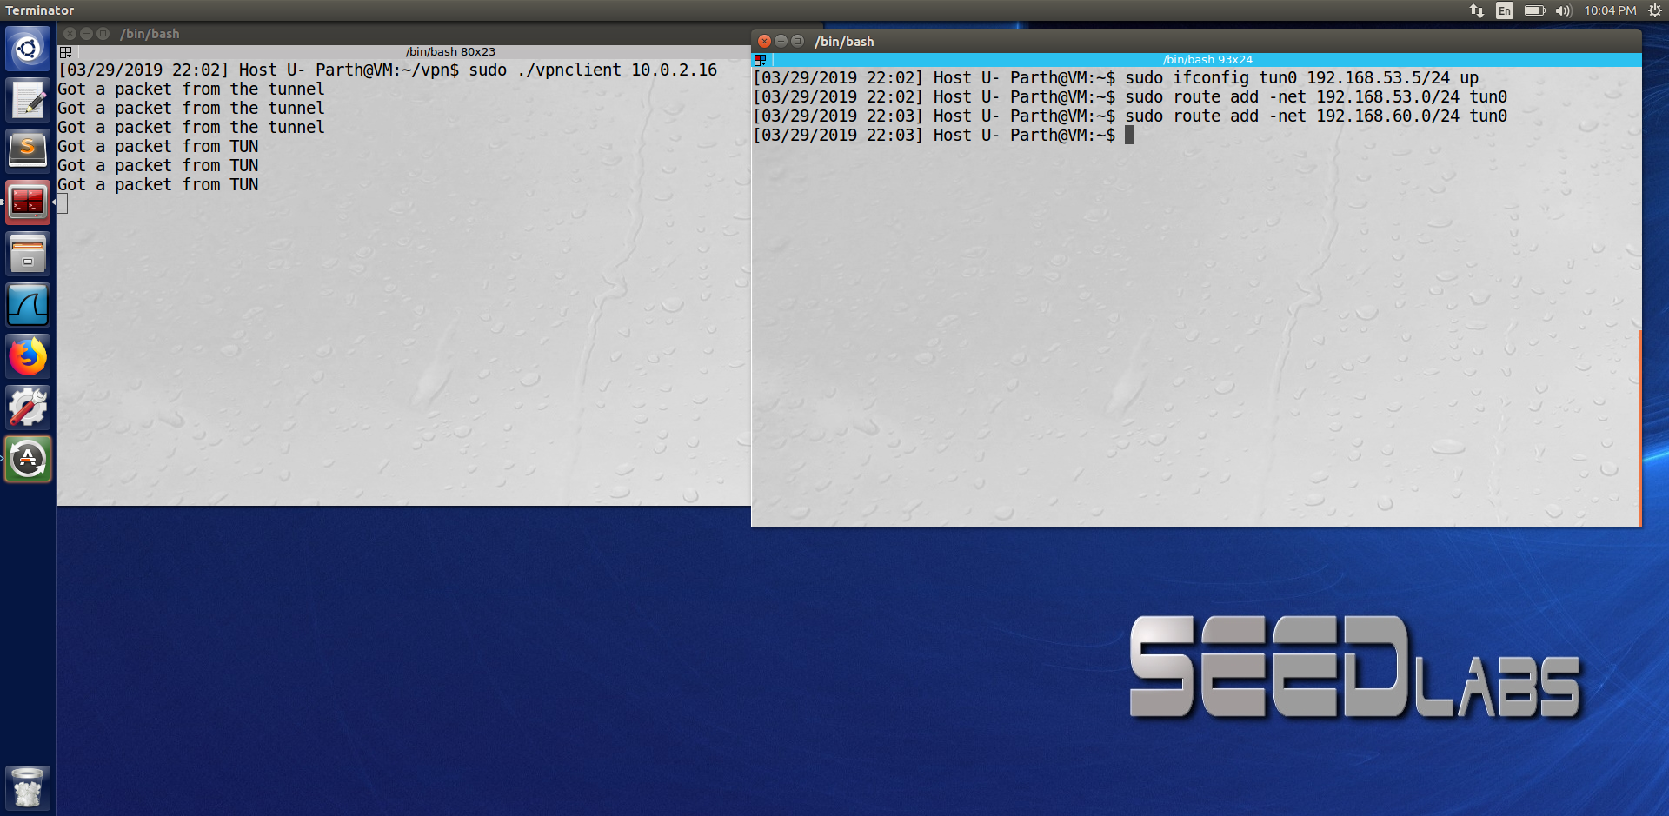

Similarly, on the client side we set up the routing path for the Host U machine to direct the traffic of IP 192.168.53.0/24 and 192.168.60.0/24 to go through tun0.

Step 4 : Setup Routing on Host V

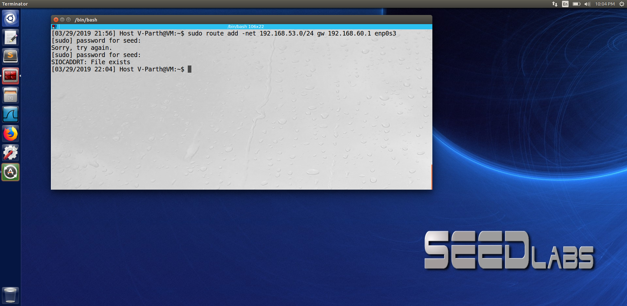

In this step we set up the routing path on host V. This is so, that when host V replies to Host U it needs to go through the routing path through the VPN server. Since, Host V being an internal network does not know where to send the packets and cannot let the packets go through any arbitrary route else the packet is not protected. The command in the screenshot above states that when the packet going to IP 192.168.53.0/24 (more precisely 192.168.53.5 – ip of the tun0 on client side) should be routed toward the router 192.168.60.1 (VPN server IP)

Step 5 : Test the VPN Tunnel

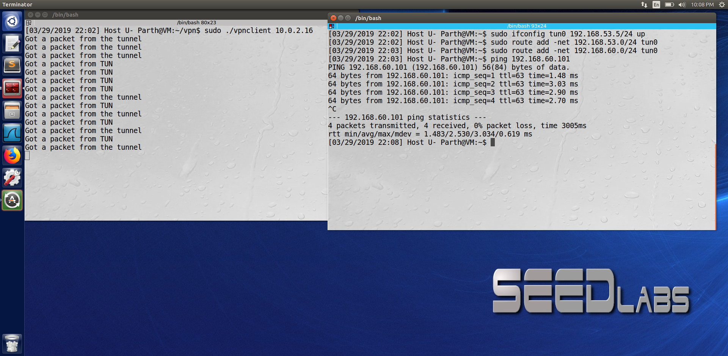

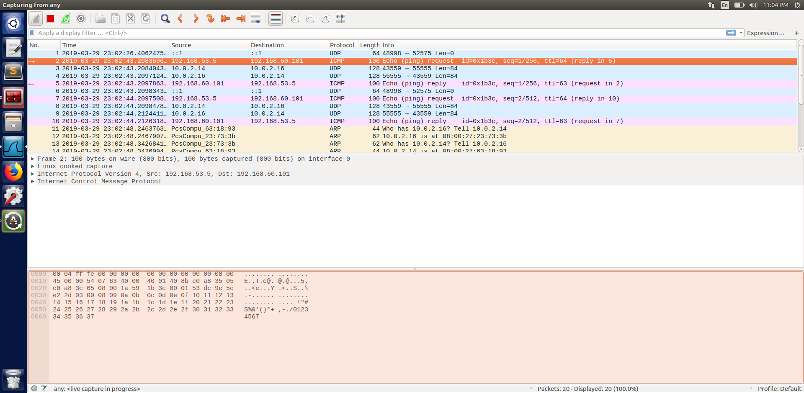

We can see from the wireshark screenshot that packet source and destination 192.168.53.5 (Client- tun0) and 192.168.60.101 (Host V) are the tunnel traffic and the rest are the normal traffic.

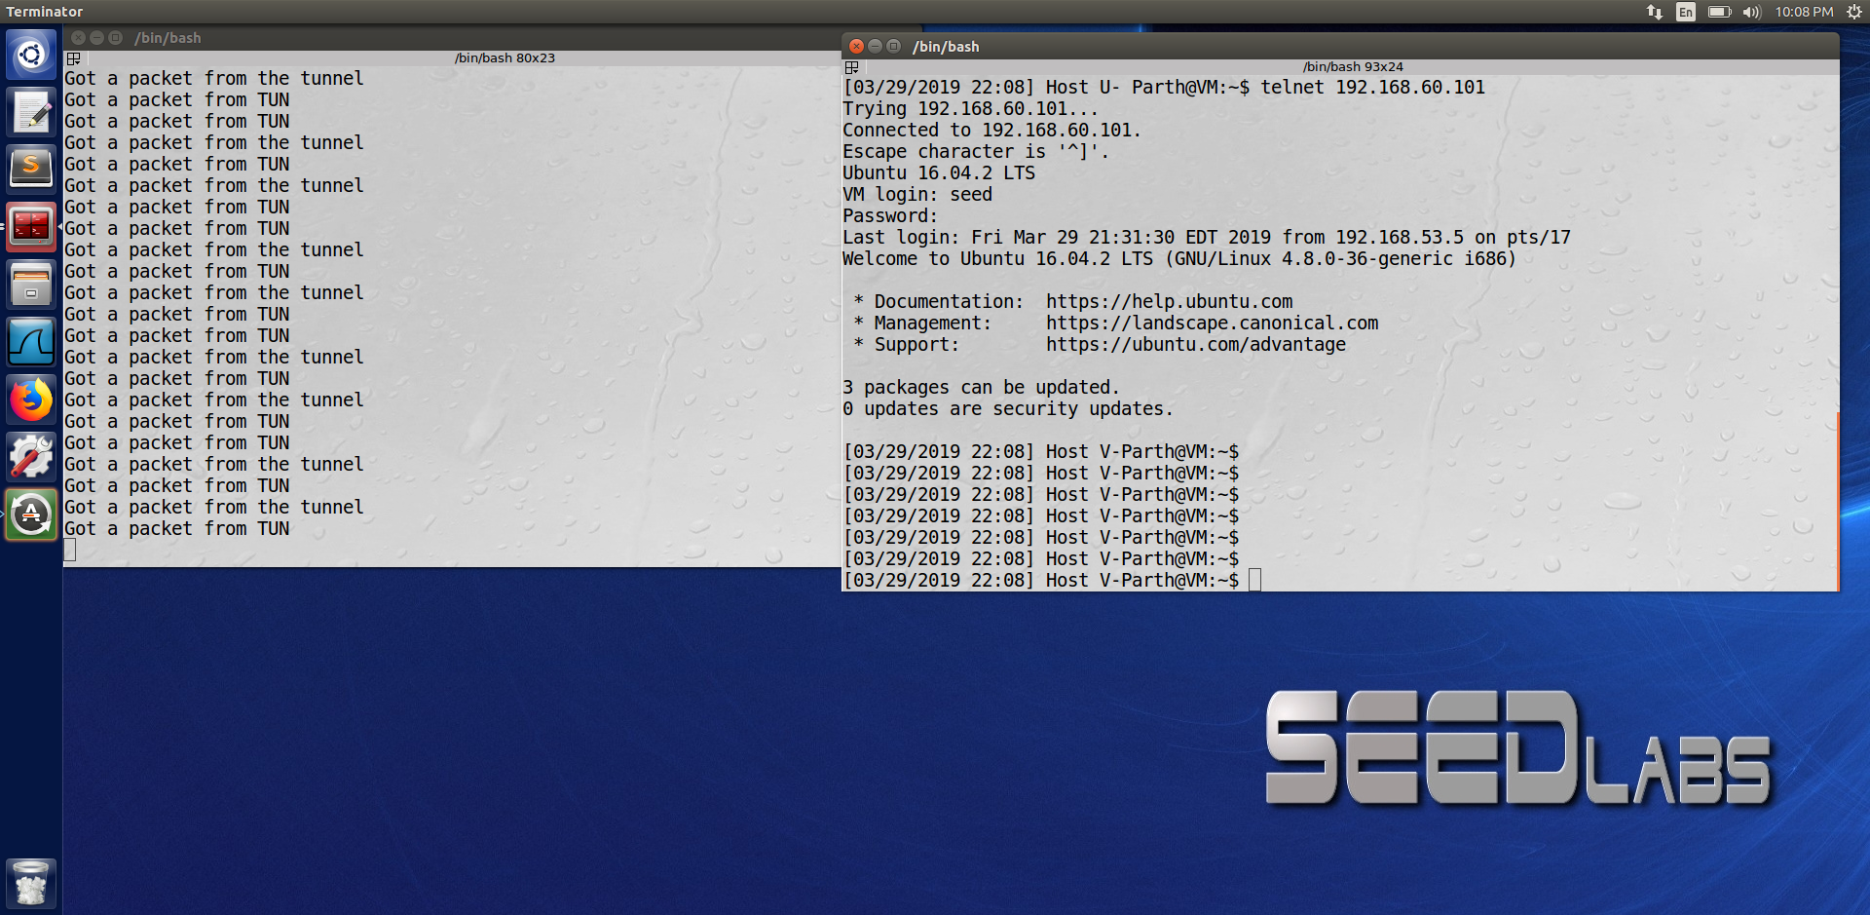

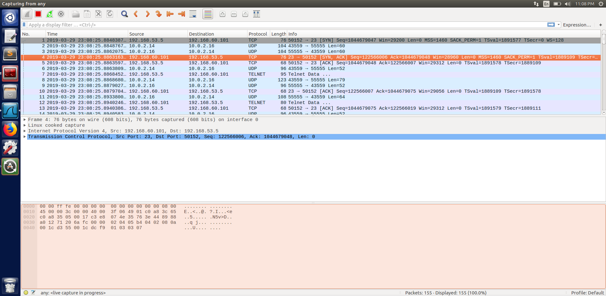

This step is just to test whether our VPN is working. That is, whether Host U is able to connect to Host V. To confirm that we first ping 192.168.60.101 (Host V) from U and then telnet to the same Ip. From the above screenshot we can conclude that we were successful in establishing the VPN connection.

The wireshark screenshot is similar to the previous one.

Step 6 : Tunnel-Breaking Test

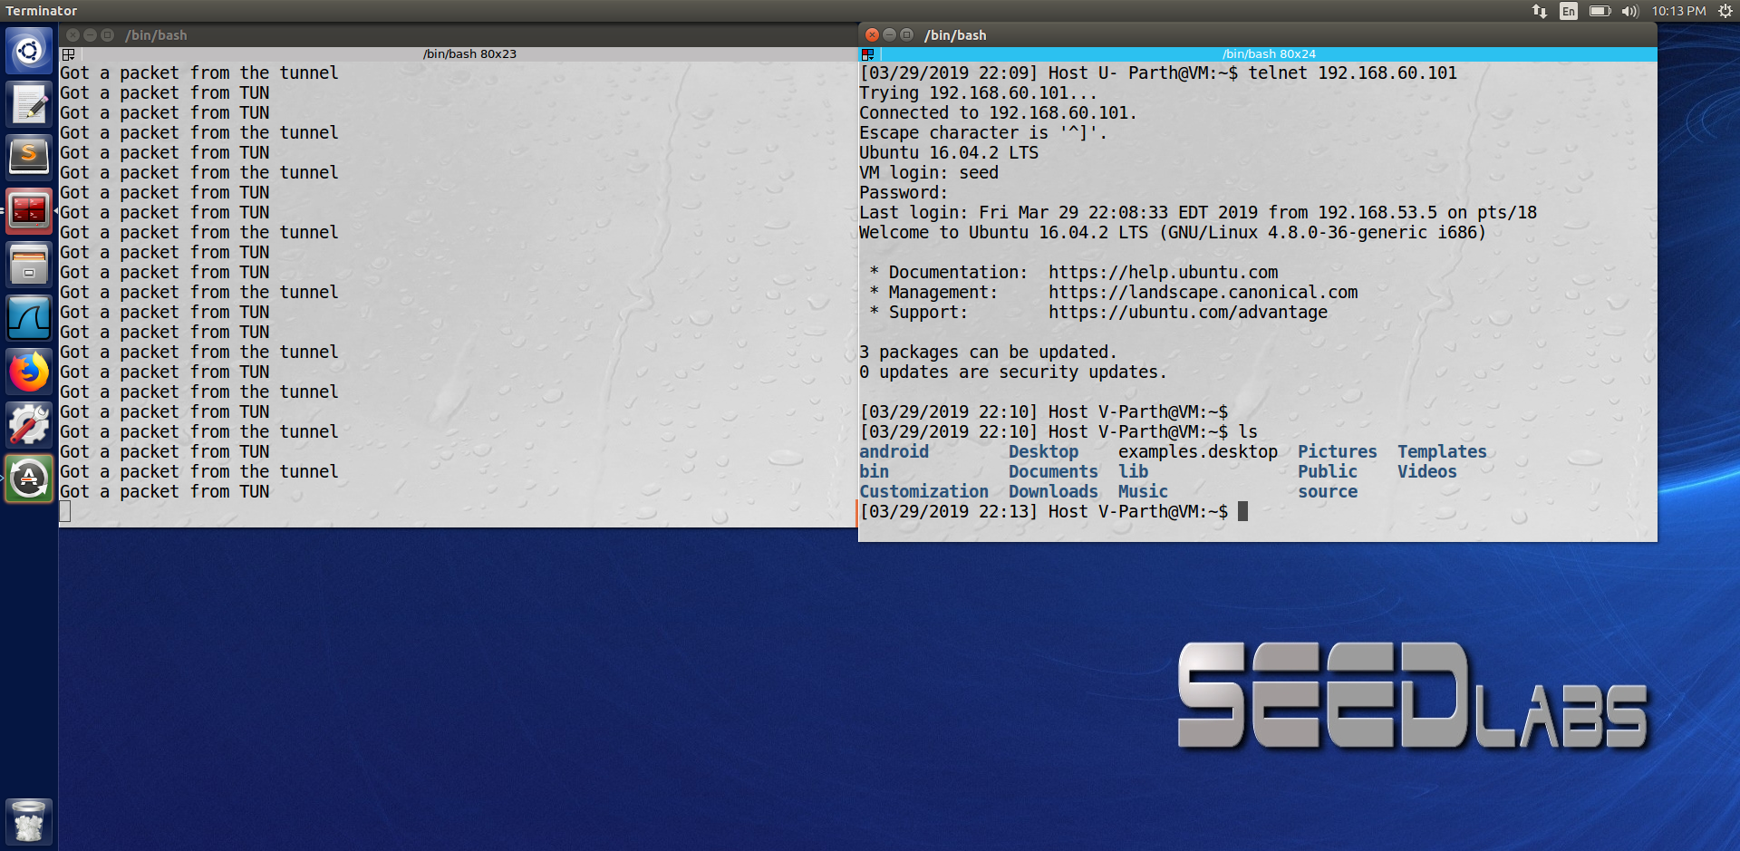

At first we can see that from Host U when we type command ‘ls’ we are able to execute that after getting logged in as Host V using telnet.

Now we disconnect using the command ctrl^c on the server machine as seen below

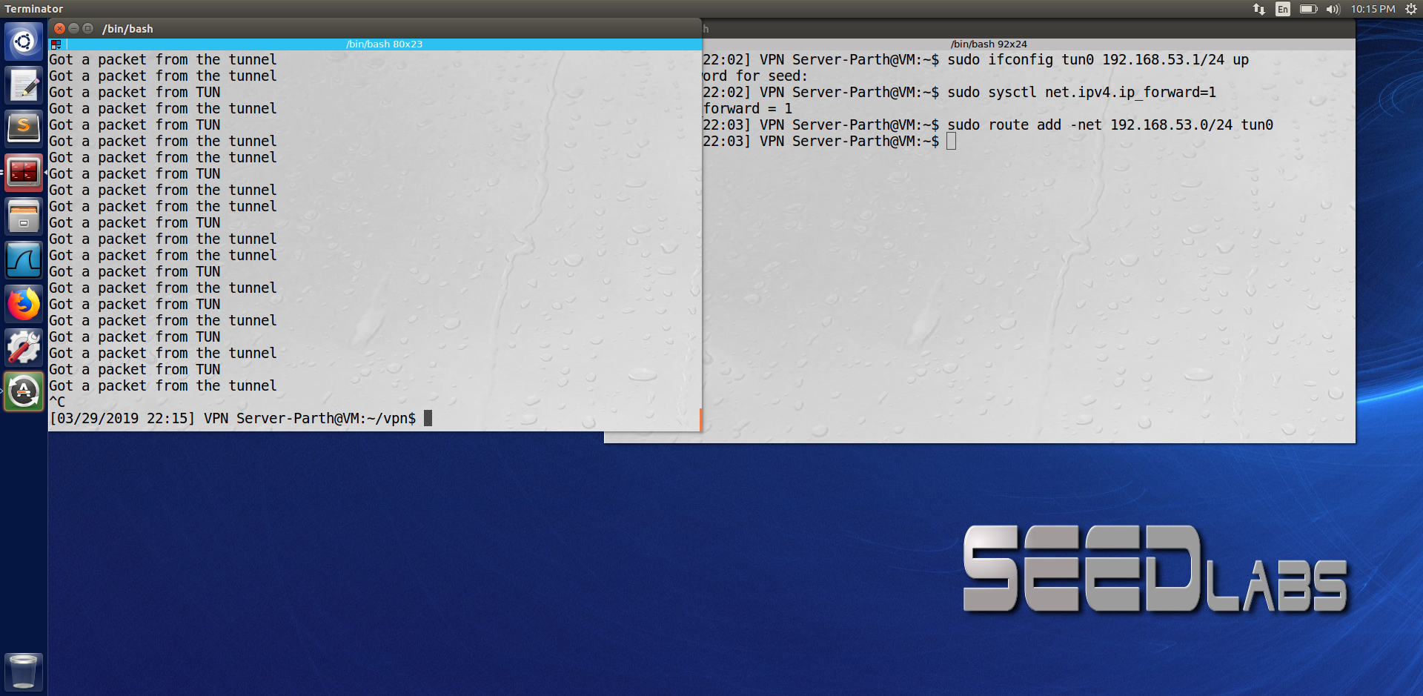

Now when we type any random letters we are not able to see that as seen from the screenshot below

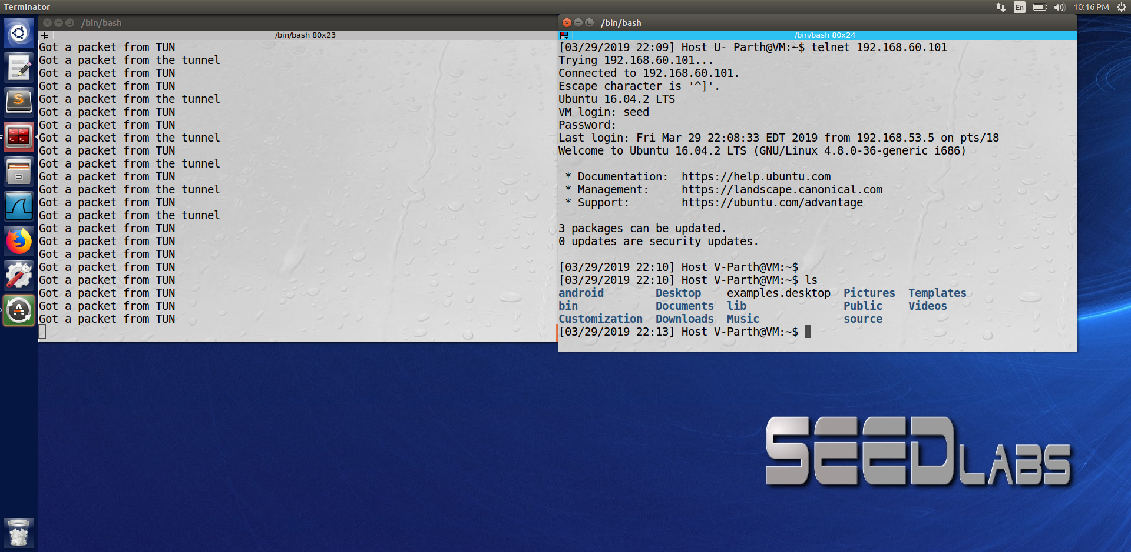

And now if we again connect the server machine we can see that the randomly typed command on host U machine is popped up.

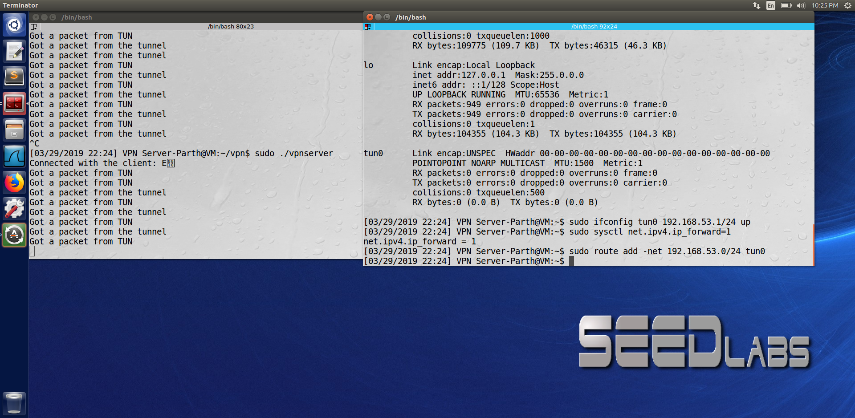

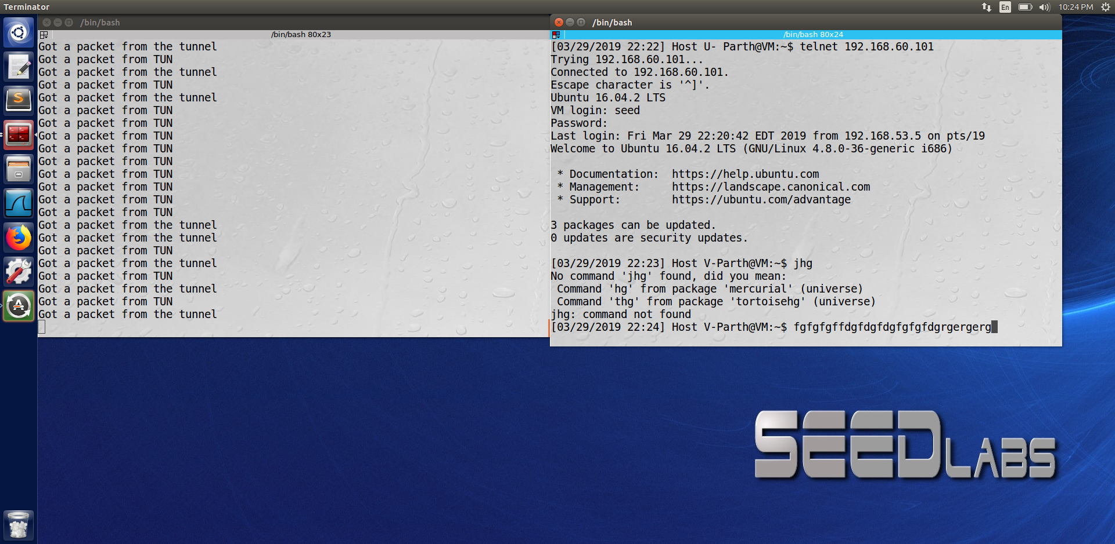

The telnet becomes unresponsive when we break the connection and then after reconnecting all the typed characters we had given reaches the telnet server which we are later able to see on VPN client.